**BCSH - Project**

**Evandro Gomez Quintino**

2960774

Submitted in partial fulfillment for the degree of

B.Sc. in Computing Science

Griffith College Dublin

06, 2021

Under the supervision of Joe Roe

**Disclaimer**

I hereby certify that this material, which I now submit for assessment on the programme of study leading to the Degree of Bachelor of Science in Computing at Griffith College Dublin, is entirely my own work and has not been submitted for assessment for an academic purpose at this or any other academic institution other than in partial fulfilment of the requirements of that stated above.



NEED TO SIGN IT BEFORE SUBMITTING

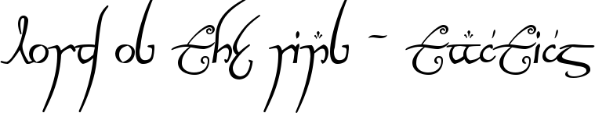

Figure 1- The Lord of the Rings - Tactics

I dedicate this project to my wife, who has always supported my dream to become a game designer and who has been beside me during all the difficulties along the way. And to myself, that beside all the odds, I managed to succeed all the barriers in order to become something that I only dreamed when I was younger.

The theme of this project was based on the “*The Lord of the Rings*” trilogy and turn based games that I have played during my life, including also chess, one of the first board games that I had learned how to play.

I hope that everyone playing this game can enjoy it and hopefully in a future soon, we will have more games made by myself in the marketing. Thanks again!

Evandro Gomez Quintino

Contents

Chapter 1. Game Design 3

Game Industry 3

*The Theme* 4

*My own experience with “LOTR”* 5

*Game Genre* 5

*Chess* 6

*Final Fantasy – Tactics* 6

Battleship 6

*2D Game Project* 6

*Characters* 6

Frodo 7

7

Sam, Pippin and Merry 7

Gandalf 7

Aragorn 7

7

Boromir and Gimli 7

Legolas 7

Gimli 7

*Map* 6

*Display Resolution* 6

*Main Menu* 6

*Background Music* 6

Game Design Flow 7

Chapter 2. Gameplay 7

The turn base system 7

Hidden Movement Mechanic 8

The Eye Mechanic 9

Pieces Movements 9

Chapter 3. Development 10

Paper and Pen 10

Game Engine 11

Setup the Project 12

Trello 12

Unity Hierarchy 13

Unity – Project Folder Structure 14

Coding 15

Photon 15

Chapter 4. System Flow 15

Chapter 5. Conclusion 15

Issues along the way 15

The incorrect Strategy 16

Project Timeline 17

Different approaches 18

Game Design 18

Coding 18

Project Timeline 18

References 20

Bibliography 20

References 20

# Chapter 1. Game Design

The following Chapter will introduce to the game industry research and cover game design ideas that I had when starting the project. Doesn’t reflect all the results achieved by the end of the same.

## Game Industry

Before we dig into the project details and design, let's have a quick overlook in the game industry.

Couple of years ago, actually a long time ago, I told my father that I would like to work in the game industry. It was 2006 and I didn’t have any idea how to do it or even where to start, but motived by my personal hobby, I told myself that would be a great idea to work closely with something that I always loved.

My father, like anyone who grew up back in the 70s, had this image that games were made for children and the profits from that were minimal. In fact, he was actually right in one aspect, the game industry by that time was small and limited by the technology so for me was really difficulty to give my first steps in this career.

Fortunately, we are now in 2021 and technology has grown in different ways that we couldn't even imagine back in 2006 and so has the game industry. As per this article in the GameIndustry.biz (Batchelor, 2020), the game industry has registered in 2020 a market worth of $174.9bn , which comparing against other cultural industries like cinema which made $100bn back in 2019 (Escandon, 2020) before the Covid-19 events, it’s an expressive difference and allow us to predict what the industry reserves for the next years.

Also motivated by the f2p (free to play) game genre, which basically only requires the device and an internet connection, this genre added more profit to the industry by allowing players to do in-game purchases or microtransactions. This way, instead of receiving profit from game sales, the studios are now constantly adding more content in-game at a low cost, which guarantees their economy. As this article from Forbes suggests (Gardner, 2020) , the microtransactions will allow the game industry to rise to 30% for the next three years, even with a declining purchase revenue of games, but motivated also by the Covid-19.

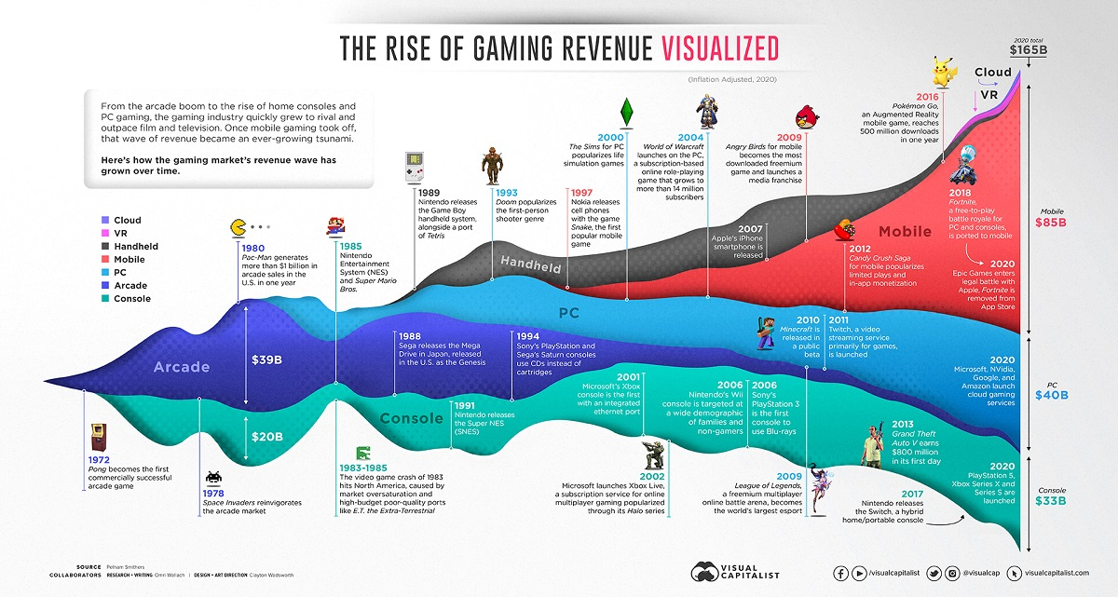The following image allow us to visualize whole picture of the game industry in the last 50 years in different platforms and genres, showing that it’s just a question of time for the same to become even greater and that new technologies like Cloud and VR have been added to a market with already different segments, which could lead also to more profit in the future.

Based on these values and projecting a blight future in the industry, its impossible as a gamer and programmer, not be interested in joining the game industry in the future. And that’s why choosing a game as my final project for the Computer Science degree was the best decision that I have made.

## *The Theme*

My game *Lord of the Rings: Tactics* is based on the famous fantasy story of the “***Lord of the Rings***” written by J.R.R. Tolkien in 11 November 1954. In this fantasy, an artefact called the “The Ring of Power”, must be destroyed due it’s evil power to corrupt and bend other races to the rings master will: Sauron.

With Sauron’s death, his spirit was still trapped in the ring and only the same could be used to bring his master back to live. In order to avoid that and bring the peace back again to the Middle Earth, where the fantasy takes place, a group of heroes from different races team up so they can bring the ring back to Mordor, the only place that it can be destroyed.

Among the heroes, we have Frodo Baggins a hobbit from the Shire, who is the only one capable to carry the “Ring of Power” and resist Sauron’s will. Also, we have three hobbits from Shire: Merry, Pippin, Sam; the dwarf Gimli; the elf Legolas and three humans: Boromir, Aragorn and Gandalf (actually Gandalf is from a different non-human race, but let’s keep this introduction short).

The “Lord of the Rings” fantasy isn’t just a great story, filled with great characters but its also a huge universe filled with massive details and content. The lore, races, the languages created by Tolkien (like the elvish), locations, side stories, etc. Everything created from scratch and rich in details…

That’s most of the reason why “Lord of the Rings” has been a success even years later its creation and off course not only by the content itself, but also the quantity of other fantasies that were influenced by the same like: Harry Potter, Dungeons and Dragons, boardgames, Narnia, etc.

### *My own experience with “LOTR”*

Most of the reason why I have decided to make a career in games development comes from “LOTR”. My first experience with “LOTR” came from the first movie in 2001 released by Warner which by that time, at the age of thirteen, I was extremely excited and shocked by the end of the movie.

I was so anxious and full of joy with the fantasy and the characters, that I started to heavily play RPG games like Tibia, Ragnarock, Magic: The Gathering (card game), Final Fantasy and others titles. The following sequence of movies, which concluded the “LOTR” plot, just added more and more love for this series.

Later on, when I was nineteen, I decided to read the books version which only added more details to my own version of the story. And finally, after managing to move outside Brazil like Frodo did when he left The Shire, I am trying to create today my own history into the games industry and find my way to Mordor.

## *Game Genre*

The game genre of *Lord of the Rings: Tactics* is mainly a boardgame, with elements from tactic’s RPGs and the traditional battle ship. The idea here was to create my own version of the “LOTR” where all the main characters are able to reach Mordor together, but they have to face a last time the Nazgul on their way to the Mount of Doom (where the ring must be thrown).

On this version, the heroes start at the top left corner where the Black Gate should be located (entrance to Mordor) and the Nazgul are located in the bottom left corner where Minas Morgul is located (the Nazgul Castle).

The following topics will cover more details about each reference for my game genre.

### *Chess*

The core mechanic for my game comes from the classic Chess game, where the thirty-two pieces must fight to capture/defend the king, which is the most value piece in the game. Also, each piece has its own set of movements and players do their moves once per turn.

In my game the logic is similar because Frodo is the most important piece and once captured, the games ends. Also, each piece has its own movement, but players are allowed to do two moves (not the same piece) per turn.

Another slight difference is that if the player controlling the Ring Society, manages to bring Frodo to the Mount of Doom, then the game ends. Which allowed me to keep the game close to the original lore, where the heroes were more concerned in destroying the ring and not only fight the enemies.

### *Final Fantasy – Tactics*

Another game that I have constantly played during my childhood was *Final Fantasy – Tactics* for Playstation1. The game was my first experience with what would become later on known as “Tactical RPG” genre, where there are characteristics from a role-playing game like equipment, skills and role-play which are combined with a battle system with limited movements/actions per turn.

The genre became popular among some players with titles like *XCOM, The Banner Saga, Fallout: Tactics, Divinity, Pathfinder* and many others (especially Japanese tittles). But for me it’s a good memory about my long hours playing and gathering the best team/strategy each save.

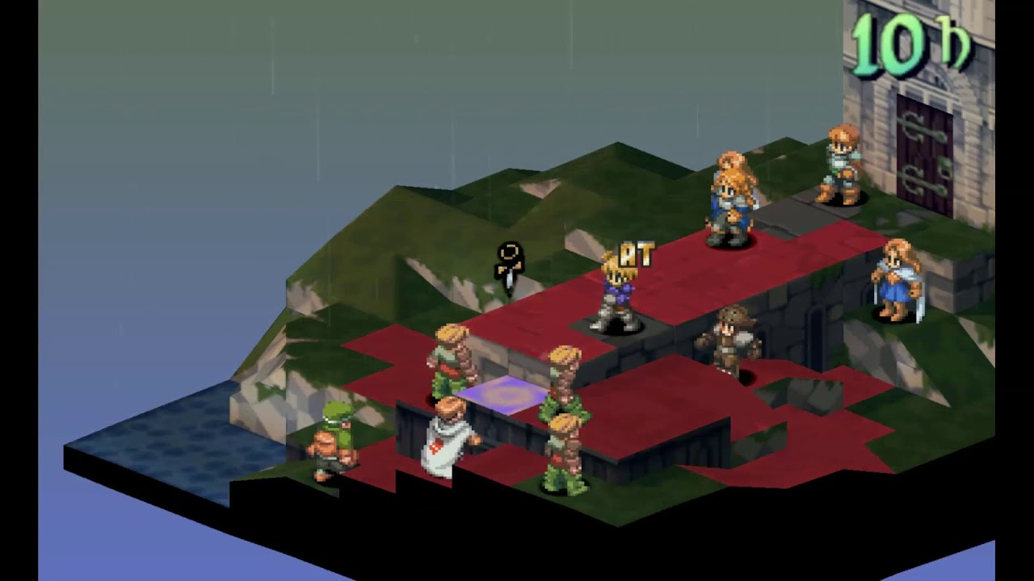

Figure 1- Final Fantasy Tactics

The original idea, for the LOTR -Tactics, was to have something close to it where each character would have at least one unique skill based on the series. Allowing this way, the player to be able to move or spend his action with skills once per turn.

### Battleship

Another boardgame that I used to play with my family during my childhood was the *Battleship*, where players have to add their ships in a board with coordinates for “X” (width) and “Y” (height). This way, without each player visualizing their opponents board, the player must guess a coordinate that will probably hit a ship.

A game with an easy system to be implemented and that could be played by anyone without a properly boardgame (just paper and pen). That’s why became so popular in the past and even in the school I used to play with my colleagues.

The reason why I would like to implement this system into my game is because the same would allow my game to be close to the experience in the “LOTR” series, where the enemies were tracking and trying to find Frodo. While the heroes would try to avoid that, but at the same time, without a clue where the enemy would hit next.

However, I would remove the coordinates necessity and only keep the idea of hiding the opponent’s pieces, so the player wouldn’t have a clue about his position on the board.

## *2D Game Project*

Due my lack of experience modelling 3D models or use programs such Blender for it, I was afraid to begin a 3D game project and don’t finish it on time for the due date. For that reason, I decided to base my project in a 2D game pixel.

This way, I would also not just create something that remind me my childhood playing classic games for Super Nintendo, but also add some nostalgic and simple visual (which my skills could achieve).

But the original idea was to create a 3D game where the camera would be positioned in an isometric way. The pieces would be modelled like chess pieces, but characters from the “LOTR” and the map would have more details and unreachable areas (like the *Final Fantasy – Tactics*).

After some brainstorm and some concern with my time available for the project, I decided to move with the idea of a simple 2D game. This way the camera was positioned on the top so the player could have the whole vision of the board.

## *Characters*



### Frodo

Among all the pieces available, Frodo is the most important and must be kept alive during the game. As in “LOTR”, his journey is to travel to *Mount Doom* in order to destroy the ring, so his fighting skills shouldn’t be great if compared with the other pieces.

Also, due the Ring of Power, his movement is limited and requires some extra turns to allow the player to move him to Mount Doom. A similar characteristic with the *King* on Chess.

|  |  |  |
| --- | --- | --- |
|  |  |  |
|  | Frodo |  |
|  |  |  |

Figure 2- Frodo Movement

Because Frodo is a hobbit and his ability to hide is high, the opponent won’t be able to visualize Frodo in the battlefield. The same will have to explore the map and reach a close distance from him to be able to visualize. That will allow the player playing as *Heroes* to create different strategies.

### 

### Sam, Pippin and Merry

The other hobbits in the story are Sam, Pippin and Merry and they have great importance in Frodo’s journey to keep him alive and protected. In my game, they can be used to lure the opponent to a different direction when trying to capture Frodo. Because their abilities to hide in the boardgame, the player playing as *Nazgul* won’t be able to visualize them and will require also to reach a close distance in order to be able to visualize them.

Their movements are the same as per Frodo.

|  |  |  |  |  |  |  |  |  |  |  |
| --- | --- | --- | --- | --- | --- | --- | --- | --- | --- | --- |
|  |  |  |  |  |  |  |  |  |  |  |
|  | Merry |  |  |  | Pippin |  |  |  | Sam |  |
|  |  |  |  |  |  |  |  |  |  |  |

Figure 3- Hobbits Movement

### Gandalf

The most powerful character in story is also a great piece in my game. Can cover great distances and in all directions, allowing the player to use him to easily destroy the *Nazgul* pieces.

Originally Gandalf would have two lives, so once killed would appear again in the boardgame after a determined number of turns. But due the Project Timeline I had to change it.

|  |  |  |  |  |
| --- | --- | --- | --- | --- |
|  |  |  |  |  |
|  |  |  |  |  |
|  |  | Gandalf |  |  |
|  |  |  |  |  |
|  |  |  |  |  |

Figure 4- Gandalf Movement

### Aragorn

Because Aragorn is a skilful warrior and he is really important in the story, his move set is great and allows the same to be able to defend the others from the Nazgul. Also, the same can cover great distances and move in any direction.

|  |  |  |  |  |
| --- | --- | --- | --- | --- |
|  |  |  |  |  |
|  |  |  |  |  |
|  |  | Aragorn |  |  |
|  |  |  |  |  |
|  |  |  |  |  |

Figure 5- Aragorn Movement

### 

Boromir and Gimli

Both Boromir and Gimli have the same movement set which reflect their close combat



### Legolas

### Gimli

**Nazgul**

**Witch-King**

## *Map*

The map was designed to be similar to the representation of Mordor in the books which the same is surrounded by mountains. Having in the top left the Black Gate, which is one of the main access to Mordor and where our heroes in the game will start, while in the south we have Minas Morgul, the Nazgul’s fortress.

Next, we have the “Mount Doom” which is the Vulcan where the *“Ring of Power”* was forged. And beside it, the dark lord fortress Barad-dûr or Dark Tower, which is described to be higher than the mountains and has in the top of it the Flame Eye.

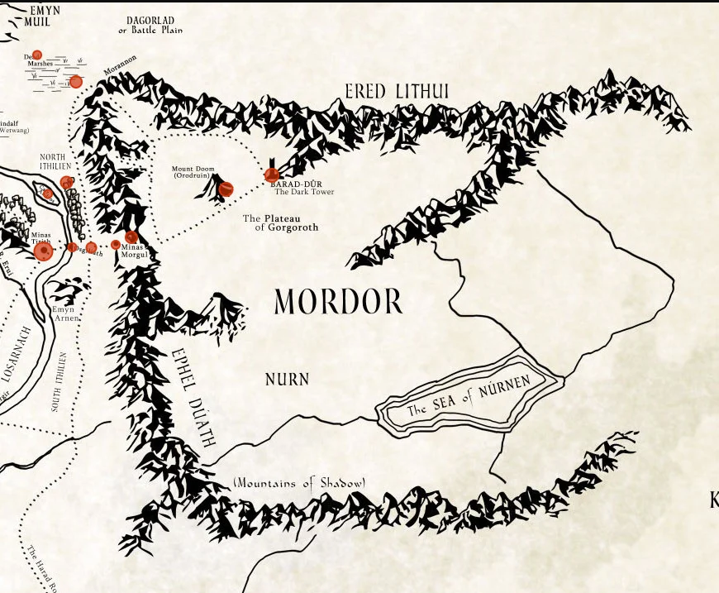

Figure 2- Original Map for Mordor

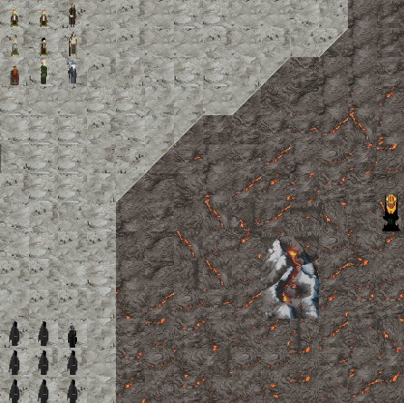Based on that description I decided to create something similar using tile maps, which would represent this scenario of destruction, dust, lava and rock. Also, the respawn position for the pieces, the Vulcan and the “*The Flame Eye*” were positioned similar as the original map described.

## *Display Resolution*

Due my decision for a simple design using pixels and Tilemaps, I choose to set the resolution to be 800x500. This way, I managed to keep a good resolution and some quality for the image. Also, because the map isn’t big, didn’t require extra resolution to show all the details.

## *Main Menu*

The first step to stablish my Main Menu was to find the best image that would reflect the dark atmosphere that is present in the “***Lord of the Rings***”. Different from the “***The Hobbit, or There and Back Again***”, which is a children’s fantasy and was the first success for J.R.R Tolkien, “LOTR” contains fantasy and dark moments where evil and good forces fight each other.

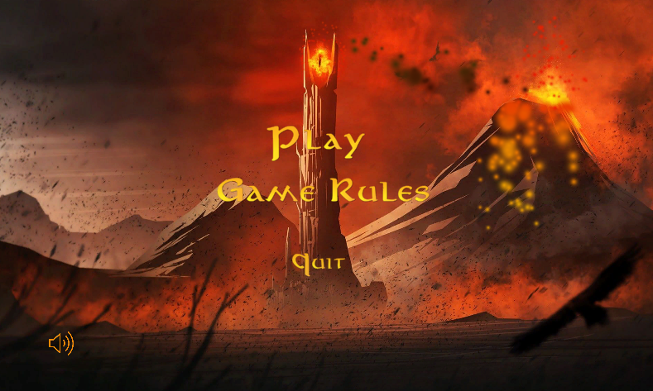Based on that, I was looking for a dark theme that would bring the feeling of “fighting” against dark forces. Also, I needed something more related to Mordor and not the movies.

Figure 3 - GameBoard

Finally, I found the perfect image, which was not just dark enough but had also the Mount Doom and the Barad-dûr with the Flame Eye. Which soon gave me the idea to add particle effects for the smoke, lava and fire effects coming from them.

The text font for the menu was also based on the font used for the movie’s title. And for the font colour I initially thought about something red/dark, but soon I realized that was just too much red for the Main menu so I changed the font colour to yellow/gold which reminds the ring itself.

The menu options were designed to be simple and divided into:

* Play
  + Which will allow player to choose between
    - Local – Two players sharing the same screen
    - Multiplayer – Players playing each one his version of the game.
* Game Rules
  + Which will contain a quick explanation of the Game Rules.
* Quit
  + Close the Game

And a sound button located in the corner left, which will allow the player to turn on/off the background music. Which is our next topic.

## *Background Music*

Before jumping into the game’s music, its important to stablish why I decided to pick up this song. If J.R.R. Tolkien was alive to watch the movie “***Lord of the Rings***” released in 2001, I believe that he would be not just proud of the quality that the movie reflected based on his books but also, he would fell in love with the music itself.

The music was composed, orchestrated, conducted and produced by Howard Shore, a Canadian composer and conductor, whose won three Academy Awards with his work in this movie and it’s memorable. After twenty years, watching this movie still brings me chills to my skin, especially because of the music.

The music captures the essence of the story, the drama, the darkest moments and off course, the triumph moments. The orchestra adds also some feeling of knowledge/old which combines perfectly with the atmosphere in the movie and the drama which the characters are involved.

Finally, after this love letter of a fan, wouldn’t be possible to create a game based on “*LOTR*” without adding the movie music itself to the game. Which again, combined with other elements like the Main Menu background image, just brings the feeling of urgency and fear of fighting Sauron’s dark forces.

### Game Design Flow

Finally, the following diagram represents the game design core idea that my game would follow, where *Player 1* would have to move *Frodo* to *Mount Doom* in order to win the game and use the heroes in the process to defend his path.

While *Player 2*, commanding the Nazgul forces, would have to capture Frodo in the process. And with the aid of *The Eye*, the player would be able to check specific spots in the map in order to locate Frodo and his enemies.

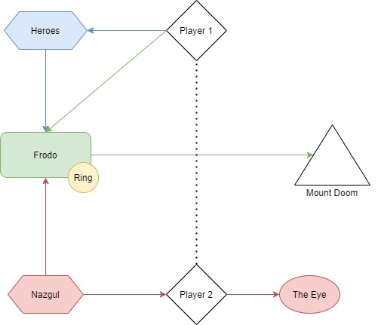

# Chapter 2. Gameplay

This chapter will cover some mechanics designed for the game.

## The turn base system

The game is based in a turn base system, which comprehends into players executing a pre-determined number of actions each turn and by the end, the next player’s turn will follow till the game ends.

It’s a pretty common type of game mechanic and has been in the game industry since the beginning. The only difference it’s because for my game, the player will have two actions to perform before his turns ends.

The two actions were added in order to speed up the game and the pieces movements and to allow the Heroes, which contain pieces with a single square movement like Frodo, to be able to move it and also a second piece for attack/defence position.

After the conclusion of each player’s turn, a message pops up indicating that the turn has ended and the next turn will start. That provides information for the user and adds some

## Hidden Movement Mechanic

Following the game design inspiration by *Battleships* classic boardgame, the hidden movement game mechanic was added to bring the feeling of the unexpected and the strategy mindset to the game. Allowing players to build this way different strategies in how to move Frodo to his destiny, leading this way to the end of the game, or by just protecting The Mount Doom against *The Fellowship.*

The mechanic consists of basically allowing the pieces to visualize at least three squares around them. Which the same is reduced in the case of a piece trying to visualize a hobbit, reducing this way range to two squares around the same.

This strategy not just benefits the player who controls *The Fellowship*, but adds a small advantage also if well used. The player could move the hobbits in different directions and force the enemy to hunt them and once found, the same could be lure to a different direction of the map while Frodo is sneaking in a different direction.

Another concept important of the hidden mechanic is to balance the game, once *The Nazgul* have better movement distance and can easily cover different regions of the map. While “*The Fellowship”* have at least five different pieces with a limited movement set, which not just reduce the capacity to move around the map, but also increases the combat difficulty.

Another curious point to add is because my decision to use pixel art and a small resolution, lead to a scenario where is difficulty to differentiate characters like Merry, Pippin and Sam. However, such negative aspect can be enhanced by the hidden mechanic, once the player controlling *The Nazgul* might not recognize exactly if he found or not Frodo. Which is again another particular event that happens in the books, when Merry and Pippin are captured by orcs but they are not sure if the same are the correct hobbit that they are looking for.

### The Eye Mechanic

Another game mechanic that I was anxious to add in the game is the Eye mechanic, which is directed linked to the Hidden Movement mechanic. Having both mechanics present in my game, would enhance the same and be so close to the lore as possible.

The Eye Mechanic would give another balance in the game, by allowing *The Nazgul* to spend one action per turn and be able to visualize five squares (cross format) anywhere in the map. With a cooldown of three turns, *The Nazgul* would be able to identify possible enemies coming close to *Mount Doom* or even locating Frodo’s last position.

Such game aspect would give a feeling of terror and again, would improve the strategy aspect of the game in such way that both players would have to take their actions well planned, otherwise they could lead their own game to an early end.

**The Mount Doom Indication**

Another simple game mechanic added to the game was the *Mount Doom* “arrow” indication. Instead of adding a single tile map different from the others, stablishing this way the destination where Frodo should go, I decided to add a ring animation that would point out the correct square.

This way, by selecting Frodo’s character, the ring is displayed over the destination where he needs to go. The same is turned off once another piece is selected or when clicking a movement tile.

The ring animation consists of a small animated ring, similar to the *The Ring of Power*, which moves in the ‘Y’ direction up and down while Frodo is selected. Such mechanic is simple, but adds more design to the “LOTR” universe.

## Pieces Movements

In “LOTR Tactics”, each piece has its own set of tiles for movement and the same reflect characteristics of the characters in the story. This way, characters with some limitation for movement like hobbits due their size, will have a proportional number of tiles while powerful characters like Gandalf or Witch King, will present a greater set of tiles.

Boardgames for example like “Checkers / Draughts” are dated of 3000 BCE and had already the concept of pieces moving accordingly to tiles and the limitation of each piece. With game development moving to the digital world, such mechanic was well adapted and implemented in the games early on.

For that reason, I have decided to add such mechanic to my game, so I could exploit its simplest structure, but adding different layers based on the characters from “Lord of the Rings”.

# Chapter 3. Development

This chapter will cover the stages that I had when implementing my project and the strategies and technologies that I decided to use.

## Paper and Pen

First step of my project was decided in many pieces of paper in format A4 and a lot of hours drawing and thinking about some mechanics that I would like to developer. This phase helped me a lot to stablish a mind map of what I was desiring to achieve in terms of gameplay and design, also was a quick introduction of what would become my game.

After some drafts, I finally managed to recreate a boardgame and using fake pieces I started to “play” what would become my digital game. First deciding how many pieces for each side; then their starting position on the map; what would be the goal for the Nazgul; what would be the goal for the Heroes; what would be winning/losing condition for both sides and finally some extra details to enhance the main ideas.

Using a Chess board, I applied my game rules and played a couple of times. Each interaction allowed me to have better ideas, remove some unnecessary rules and improve this way the overall idea about the game.

Once the core of the game was decided, I started to upload all my notes and draws to the computer, where I would organize everything and stablish some milestones for the project.

## Setup the Project

### Trello

It’s important to state that Trello had a great contribution for the overall project in terms of organization, timeline and agile process. Using Trello, I was able to organize my ideas into categories, which I would use as milestones for the project along the year.

The project was divided into:

* LOTR 1.0
  + First stage is where I setup the base structure for the game on Unity: boardgame, GameObjects, Pieces, Grid, Game Rules, Movement for the pieces, Turn system, etc.
* LOTR 2.0
  + Second stage I added minor features and details like: Mount Doom, basic UI, The Flame Eye, improve the movement set, etc.
* LOTR 3.0
  + Here I planned to add: main menu, fire/lava animation, sounds, multiplayer system, etc.
* LOTR 4.0
  + And finally, the last stage should be dedicated to: testing, prepare game documentation, fix major bugs and create the demo.

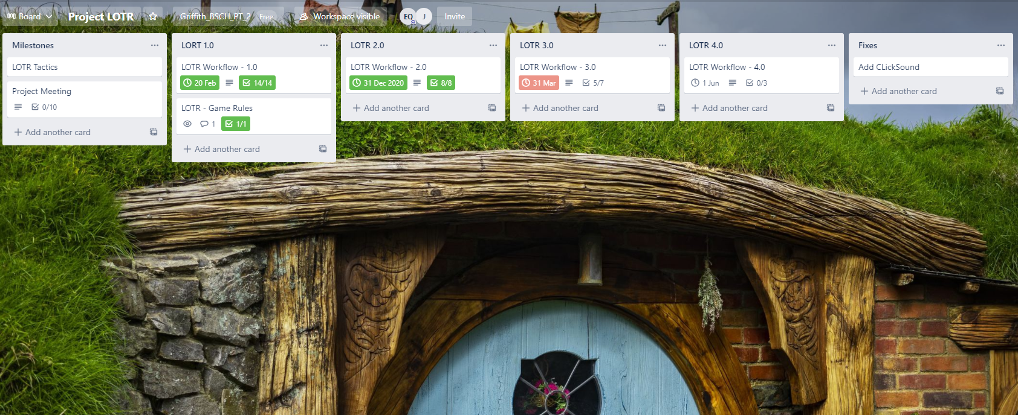This simple structure helped me a lot to organize myself every day before starting working on the project and it’s something that I have implemented for my own life and workday. Preparing myself for the task before starting it, allows me to visualize possible solutions and problems along the way and quickly adapt myself to it.

Figure 4- Trello Setup

## Game Engine

One of the biggest steps that we have to do before creating our own game is to decide which game engine, we will end up using. There are many different game engines available in the marketing, for different proposes, project sizes, necessity, lacking of coding or even using specific languages.

For my project, a simple 2D game based on pixels, most of the game engines would work fine, however I decided to use the Unity to build my game for a couple of reasons.

Firstly, Unity is used in the game development module in Griffith College, which would allow me to gain more experience while having classes and doing my project. Also, I would be able to bring some questions regarding the engine to class related with my own project.

Another point would be my previous experience studying and practicing with this software along the last couple of years. This project was my first time to get my hands in a big project and manage to produce a playable game from it and such previous experience, gave me confidence in the engine and the results that would I be able to accomplish.

Technical points to choose Unity over such big game engine software like Unreal would be the wide community that Unity has; the programming language is C#, while Unreal uses C++ and for gamming purposes, C# as a better performance ; Unreal is well-known by its graphic qualities but I believe such potential would be wasted in my project and finally, Unity has a huge store with many mods that I could eventually use to add mechanics, characters, mods, etc.

Finally, a personal reason that I could point out as one of the motives for me to consider Unity as my game engine is because in the last couple of years the same has been responsible for big games to be released, especially indie, games like: *Cuphead, Escape from Tarkov, Hearthstone* and *Hollow Knight* are some of the examples.

So based on these points, I believe that choosing Unity was the best decision made and the one that would suit my timeline available for learning/implementing the game engine as per the project’s tasks. Other game engines would require some time for adaptation and learning that could eventually affect my project in the future.

### Unity Hierarchy

If there is something that I have learned during my experience working with Unity it’s the importance of the hierarchy and the organization associated with that. Similar to the code itself, which requires some structure and pattern in order to be better understood, the hierarchy may be enhanced by this practice also.

As we can see below, both Hierarchies are from the two scenes present in my game. By using a simple technique to add empty Game Objects and naming them accordingly with the category that I want to represent, I can divide each component in a specific category.

Even for a reader, without any experience with my code and project, it’s easy to identify what each GameObject is referring to. Such process not just helped me to improve my organization but can I also avoid small mistakes, unnecessary content in the hierarchy and improves my understand about how the game is working.

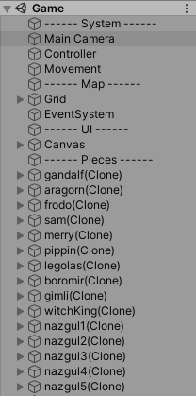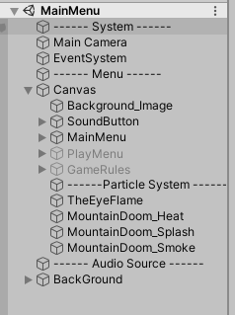

### Unity – Project Folder Structure

Another key point really necessary to keep the project organized and structured is how the folder is setup. In order to keep the project clear in such way that anyone accessing the same for the first time can be able to locate a component, I had to organize it into different levels.

The folder structure was divided into:

* Fonts
  + Adding all font styles and Text Mesh Pro components
* Audio
  + All the audios resources: music and click button sound event.
* Animation
  + All the animations present in the game.
* Photon
  + Package used by Unity to allow us to create and run games in multiplayer.
* Prefabs
  + Where all the prefabs for my game objects would be stored
* Scenes
  + A scene in Unity would be like a different layer in the game, such as main menu; different level in a puzzle game; a cinematic used during the game, etc. So, for my project, I used this folder to store the scenes for *Main Menu* and the *Game* itself.
* Scripts
  + Where all the C# codes were saved for my project.
* Tiles
  + The tile maps and images used to create them. Here is where the boardgame components to create *Mordor* were saved.

## Coding

## Photon

What is Photon?

RPC

# Chapter 4. System Flow

This chapter will present the design and flow of my project.

## Class Diagram

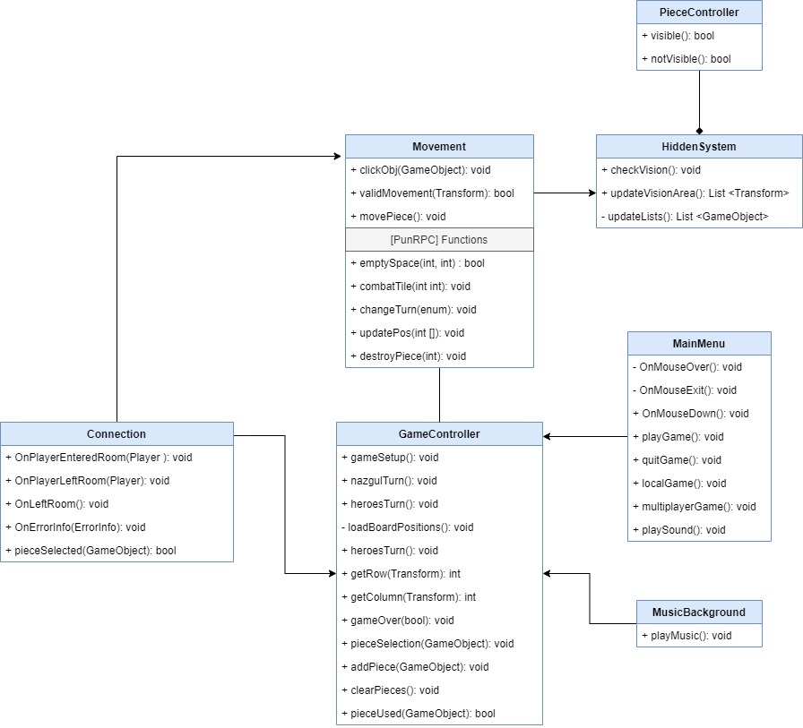In order to better understand the project flow and how the coding was designed, the following class diagram represents all the classes present in my project and, the relationship between them, their functions, parameters and return values. That helps us to visualize the system and to have an overview of each element.

### Classes Overview

The classes were designed to be built around the *GameController* and Movement, that would contain the core mechanic in the game and the main functions in order to make the game run. Game Controller contains functions related with the setup of the game like preparing the turn phase for each player, creating the boardgame to store all the pieces, recording pieces already used in the turn, etc.

*Movement* class was designed to cover all the functions around the piece’s movement in the boardgame, this way it contains functions like checking the piece clicked, checking the movement path for the same, executing the movement, checking the children related to the object in movement, etc. Also, we can find here some functions that will be called by the multiplayer mode, the PunRPC functions, which in general will repeat the same structure in the local game but adding some differences like how the same will be transmitted for each user or in which order.

*Connection* is a class build-in with Photon and was added in the project after importing the same from the Unity Store. It contains a series of functions that can be overridden so we can expand the same and add customs logics as per game requirement, but in my project, I have basically used the same for setup the rooms for multiplayer connection, distinguish the players connected and testing.

*MainMenu* contains all the functions related with the *Main Menu* scene, where the player will find the first screen before jumping into the game. Here we will have functions for start the local mode, multiplayer mode, some TextMesh Pro functions to animate the text when mouse hover, quitting the game and playing sounds when clicking the button.

*MusicBackground* was added just to be responsible to set On/Off the background music. I could add it to the *MainMenu* and turn it in a class to control the UI components, however I thought that adding a separate class would help me to keep my code clear.

*HiddenSystem* controls the game mechanic that hides enemy piece’s movement from players and have the *PieceController* class dependent on it. *HiddenSystem* has functions like calculate the overall vision of the pieces, update the same based on the piece’s movement and by using *PieceController* functions, *HiddenSystem* can interact with the pieces and enable/disable their sprite which will “hide” them.

### Sequence Diagram

The following sequence diagram shows how the order in each Game Object occurs. Here its possible to see that the player will interact with the Main Menu, which will lead them to the Game.

Once playing, both players will play their actions in a turn system base and once the game is finished, both will have the opportunity to retry the game or end the application.

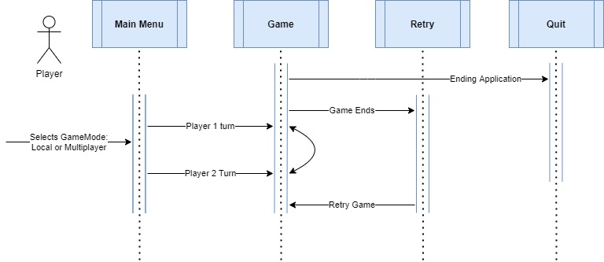

# Chapter 5. Conclusion

This chapter will conclude the documentation and add my personal experiences with the project, difficulties/challenges and solutions applied along the way.

## Issues along the way

During the project I have faced different issues along the way. Most of them were simple/medium issues, related with my lack of experience programming games which I managed to solve after a given time.

Among them, one that took some time to solve for example was the boardgame mapping, where I wanted to create a GameObject array containing all the pieces and their respective positions. Everything packed as prefabs and instantiate them in a multidimensional array where my [0,0] would comprehend the centre of my map.

The issue started when instantiating them in the boardgame, once their GameObject position wasn’t synchronized with the grid position. In order to solve that, after a couple of days, I managed to convert each GameObject position to a specific Grid Position and match this way the squares.

Off course, by the end of my project I realized based on a course in Game Development that I bought, that an easiest solution would be change the grid’s position for example and have this way a better logic.

All these issues were normal in a game project and could be solved after some time, however my biggest issue was related by adding the Multiplayer feature which affected not just the overall project’s timeline but also resulted in a high demand of energy to solve it.

### The incorrect Strategy

Again, for my first big game project, I have the feeling that the project was well executed based on my lack of experience. However, I have to point out that some issues along the way were escalated due an incorrect strategy that I decided to follow in the beginning of the project.

In my Game Design phase I decided to stablish the core of the game that would be something really similar to a chess game but with “LOTR” theme. This way, some mechanics were not present in the project in the first phase and here is where the reason for my main issues with the multiplayer started.

After realizing that my project wasn’t much complex and I still had some time to improve it and add more feature, I started I second Game Design phase where I would implement more mechanics and features, including the multiplayer. This way, I would allow my game to be played in two different instances instead of just a local machine.

Well, after most of the core game has been created as a local game mode, by adding the multiplayer feature I just not compromised my previous logic but also, I had to redo most of the work already done. And even wasting days trying to implement it, without compromise too much my original logic, by the end I realized that would be more professional and clearer to have two different coding logics for each game mode, instead of trying to bending the local mode into the multiplayer.

So, after such experience has been achieved, I can clearly state now that my strategy should be since the beginning to decide if I wanted to add or not the multiplayer feature. If added into the project, then due the complexity of the remote procedure calls, would be better to start coding based in the multiplayer logic and once done, adding the local mode would be much easier.

### Project Timeline

The project officially started during 2020 second semester. After ending the last activities for the third year, I decided to have a look in different projects that I would like to work on for course conclusion. In October, when we had to submit a project planning describing our ideas, I had already for a couple of months the intention to developer a game based on “LOTR”.

After having my project approved, I decided to breakdown the project into categories and milestones which I should accomplish along the next year, which I have described in the Chapter 3. Setup the Project – Trello.

The project progressed well till the start of the second semester for the 4th year (February). Once the classes begin again, the assignments started to become a problem for a timeline.

I lost track of the project and because I had already done much work during the last couple of months, I decided to focus on the assignments when I should actually have dedicated at least 10% of my available time to check my own code or do some small changed, but never fully stop the progress.

By the end of the assignments, I was obliged to take off two weeks from my work so I could speed up the project and put it back on the tracks again. Not just the project wasn’t fully completed, but the documentation wasn’t done yet.

The last couple of weeks, before the submission, have been toughs due my issues trying to finalize the project and its multiplayer game mode. Also, writing the documentation has been part of my daily project work, which I have managed t write a couple of pages every day in order to achieve the minimum requirements.

**My experience with the project**

(How has my experience during the planning/execution of the project)

## Different approaches

During the execution of the project I realized that some strategies/decisions were not well implemented or didn’t achieve what I was expecting. Here I am adding some key points that I would do differently when approaching a new project in the future.

### Game Design

### Coding

### Project Timeline

I really don’t believe that I have failed with my project timeline in the beginning of the project, however due the academic semester, I have indeed missed the opportunity to accomplish the expected results and I have failed to dedicate more hours to the project.

The lesson learned is that I should have divided assignments and the game into different projects and added an exclusively timeline for each one. Instead of completely stopping one, would be better to add small tasks for the game project for example, while dedicating more energy and hours to the assignments.

This way I believe that I would at least be able to visualize future timeline issues with my game project and would have some time to adjust myself in order to achieve the expected results. For my next experience, I will extremely pay attention to my timeline and stablish a better plan.

**The project conclusion**

# References

### Bibliography

# References

Batchelor, J. (2020, 12 22). *GamesIndustry.biz presents… The Year in Numbers 2020*. Retrieved from GamesIndustry.biz: https://www.gamesindustry.biz/articles/2020-12-21-gamesindustry-biz-presents-the-year-in-numbers-2020